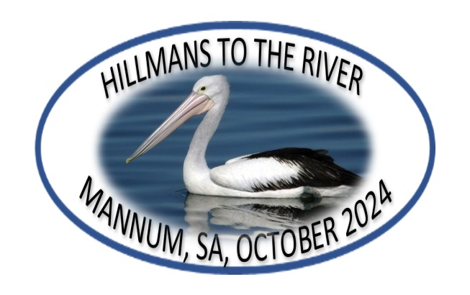
17TH NATIONAL HILLMAN RALLY
MANNUM, SOUTH AUSTRALIA, FRIDAY 18 OCT – TUESDAY 22 OCT, 2024

SIGN UP FOR INFORMATION
The Hillman Car Club of South Australia will be hosting the next National Hillman Rally at Mannum in South Australia. Mannum is one of the major ports on the River Murray and the rally will have a strong riverboat theme. Rally headquarters will be the Mannum Motel and there is also the Mannum Caravan Park directly across the road with a wide choice of self-contained cabins – so there is a range of accommodation to suit everyone.
Sign up below to receive newsletters and updates via email as planning progresses.
Name
Address
Email
Phone

SEND THIS FORM TO STEVE FREEMAN: sblafreeman@optusnet.com.au
or post to: 7 Richmond Rd, Westbourne Park, SA, 5041

More information? Check out these websites:–
Mannum Motel
Mannum Caravan Park (BIG4 Breeze Holiday Parks)
Mannum Visitor Information Centre & Mannum Dock Museum

